Dear Parents and Students,
Welcome to 10th Grade English! I am so excited to be your teacher this year.
Course Description:
Pre-AP English II is a course of multicultural literature and writing strategies. We analyze and interpret various genres of work for the author’s purpose, literary devices, rhetorical strategies and voice. We will write through each stage of the writing process to show an understanding of the English language. We will develop as critical readers by studying novels, short stories, poetry, essays, and nonfiction. Film, art, and music are integrated into each unit for students’ enrichment of culture and expression.

This is a Pre-AP course recommended for highly motivated students who will dedicate the extra time and attention that a demanding course requires.
All parents and students should understand the rigor of the class and the commitment required by the student. The goal of this course is to prepare students for Advance Placement, college-level courses.
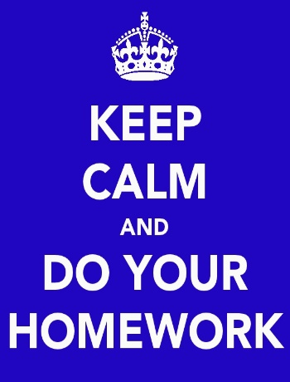
Please read the following information carefully:
Homework:
The daily average for homework will be 30-45 minutes. Students are often assigned reading or long-term assignment projects that require them to plan their time carefully so that they are not overwhelmed by deadlines. Developing self-discipline in the areas of time management is a goal of all Pre-AP/AP classes.
Late Work:
Late work is NOT accepted in Pre-AP/AP classes. A grade of a 0 will be given for any assignment not turned in the day it is due. If a student is absent the day that an assignment is due, then he/she must make arrangements for the assignment to be brought to the teacher the day after they return.
Reading:
Students are encouraged to buy their own books so that they can annotate as they read. If purchasing a book is not feasible, accommodations will be arranged. Students will be working with the following books this year in class (starred books- consider purchasing your own copy):
The Great Gatsby F. Scott Fitzgerald *
Julius Caesar William Shakespeare
A Lesson Before Dying Ernest Gaines*
Antigone Sophocles
Students will also be required to present book reports during the school year. Rubrics and expectations will be handed out to students concerning this project along with the corresponding due dates. Students need to be continually reading; that is the purpose of the book reports. A book list of acceptable books will be handed out to students in class.
Expectations About Reading:
- Assigned reading is done outside of the class most of the time.
- Discussion of outside reading, particularly at the upper levels, is most often done after the entire work is read.
- Students are expected to read the books required- NOT depend on Cliff’s notes or class discussion for understanding.

Essays:
Writing is an integral part of every Pre-AP class. Students will be required to write process papers of varying lengths throughout the year. In class, timed essays will be assigned on every grade level. Papers written outside the class must be typed. Students are, of course, expected to turn in original work. Plagiarism, like other types of cheating, result in a 0 for the assignment. Plagiarism, in its simplest terms, means presenting as one’s own any or all portions of someone else’s work, including papers found on the internet.
Tutorials:
All students should attend tutorials when they need help with assignments. If a student is failing, they are required to attend tutorials. I offer tutorial every Wednesday 3:15-4:05 or by appointment. If students cannot attend on Wednesday then they need to arrange accommodations with the teacher.
Cell Phones: Cell phones should be silent and out of sight during class. If students are using phones in class, Ms. Lindquist will put cell phones in “jail” until the end of the period.
Behavior:
Students are expected to act like mature, young adults. If a student is found breaking any rules from the student code of conduct, disrupting the classroom environment, or being disrespectful in any way, there will be consequences. I want every student to be successful. I will be communicating with you if a student is disruptive or not performing to the expectations of the class.
Necessary Materials: | Recommended Materials:
1) 3-Ring Binder or folder  2) Pencils  3) Paper  4) Two composition notebooks dedicated only to English class.  5) Your copy of the summer reading. | 1) Highlighters  2) Index cards (for vocabulary study)  3) Glue or tape  4) Copies of the novels we read  The materials above are not required but would be very useful.
Students will need both composition notebooks starting Monday, Aug. 20. If you have difficulty getting any of these, please talk to me, because I can help you get them.
I’m looking forward to a great school year. Thank you for your support at home.
Scheffie Lindquist
English 1 & Pre-AP English 2
G-114
281.261.9239 Ext. 3907

Student Signature: _________________________________

Parent Signature: __________________________________

